**Indian-Startup Ecosystem:-**

**Index:**

* Introduction
* Review of Literature
* Need of Study
* Research Design
* Data Collection and analyses
* Findings and Recommendations
* Conclusion
* Bibliography
* Appendix

**By.**

**Rajat Joshi , 22108054**

**Vishal Pandey , 22108056**

**Rahul Saini , 22108039**

**Punit Gupta , 22108053**

**Shubham Soni, 22108019**

**Sahaj Verma, 22108021**

**Introduction:-**

The startup ecosystem in India has attracted a lot of attention, which is indicative of its emergence as a vital driver of job creation and economic progress. In the past twenty years, there has been a notable shift in the Indian startup scene. Even though a few firms surfaced in the early 2000s, the ecosystem was still developing, as seen by the lack of investor activity and the dearth of incubators and accelerators. But the situation has changed, with an increase in the number of startups and the growth of support systems in many forms.

This study explores the Indian startup ecosystem with the goal of providing a thorough understanding of the factors that propel its expansion as well as the difficulties it faces. Through qualitative research methods such as expert interviews conducted within the ecosystem, this study investigates the evolution of startups over time and the resources available to overcome obstacles and capitalize on opportunities. This study acknowledges that innovation and entrepreneurship encompass non-tech, social, and micro- entrepreneurs in addition to technology-driven startups.

The vast market potential, quick economic development, rising incomes, the demographic dividend of a young, aspirational population, and the country's rich diversity are some of the key growth drivers in the Indian startup ecosystem. Notwithstanding the difficulties brought about by regional differences, diversity has a double-edged effect, enabling effective solutions to meet a range of client needs both locally and internationally. Given India's dynamic economic environment, the government launched the 'Startup India' initiative in 2016 with the goal of fostering innovation, long-term growth, and employment generation. The Indian startup ecosystem is vital to creating jobs, drawing capital, advancing research and development, and democratizing the benefits of technology, particularly in rural areas. It has produced a record number of unicorns and seen significant investment in recent years. The Indian startup culture is set to become a vital force in shaping the country's economic future.

The Indian startup ecosystem is mainly consisting of four pillars and these four pillars are:

1. Support from the Government: "Startup India is a premier government program that encourages innovation and entrepreneurship, generating jobs and long-term economic growth. Currently home to more than 60,000 startups and 100+ unicorns, India has the third-largest startup ecosystem globally. Government programs provide loans, tax breaks, opportunities for skill development, and procurement advantages. Prominent initiatives comprise SIP-EIT for patent protection, Pradhan Mantri Mudra Yojana for microenterprises, and ASPIRE for support to agro-businesses. Credit delivery is facilitated by the Credit Guarantee Fund Trust, while industry-academia collaboration is encouraged by the Multiplier Grants Scheme. In order to support India's transition to self-reliance, other programs like SPRS, CRG, High Risk and High Reward Research, Design Clinic, and Zero Defect Zero Effect are designed to foster innovation and business growth.
2. Access to Capital: This has shown to be a key driver behind the explosive growth of Indian startups. After overcoming previous obstacles, the startup funding landscape has changed dramatically. As a result of increased investor confidence, India today has a growing ecosystem of angel and venture capital firms. This increase in investor activity over the last few years has resulted in an incredible increase in capital inflow for startups. Notably, Indian startups were able to secure a record-breaking $10.1 billion in funding in 2021, according to Tracxn, a well-known venture intelligence firm. This achievement highlights the vibrant financial support available for entrepreneurial ventures.
3. A Growing Talent Pool: In many respects, India's growing talent pool is a major force behind entrepreneurship. First, a workforce qualified to satisfy the needs of both domestic and foreign companies is produced in India thanks to its advanced educational system and emphasis on technical skills. Indians are skilled in navigating international markets due to their exposure to a wide range of cultures and ability to adapt to challenging circumstances. In addition, the increase in enrollment in higher education and the diversification of fields offers people the ability to think critically and solve problems, which promotes entrepreneurship. Furthermore, Indian talent has been instrumental in fostering innovation and leadership in global tech giants and startups. All things considered, India's expanding talent pool stimulates entrepreneurship by offering knowledgeable, flexible, and creative professionals.
4. A Supportive Culture: With a thriving startup ecosystem that boasts over 60,000 startups and the creation of 42 Unicorns in 2021, India's entrepreneurship culture is built on innovation and risk-taking. Due to the fast expansion of business opportunities brought about by the Indian economy, there was a surge in entrepreneurship in the early 2000s. India's entrepreneurship is supported by a number of important factors, such as the country's strong economic growth, a risk- taking and innovative culture, a younger generation that isn't scared to start their own business, and India's ranking as the fourth best country in the world for entrepreneurship. The economy's liberalization in 1991 was a turning point that gave entrepreneurs a lot of. Notable examples of Indian entrepreneurship include the social enterprise Jaipur Rugs, India's status as the third-largest startup ecosystem globally, and the impressive creation of 42 Unicorns in 2021.

**Review of Literatures:-**

1. **Mallikarjun M. Maradi (March 2023)** stated that, Bharat has come out world 2nd biggest startup environment country after the United State. According to the article India is very well country for Startup and growing very fast. In the Global Startup Ecosystem report 2022, Indian cities like Bengaluru, Mumbai and Delhi are ranked amongst top 40 startup hubs across the world. In 2021, 33 startups of India entered in the unicorn club and Indian startups have raised approx. 24 billion dolor. And in 2022, 13 more startups added in Unicorn Club. And the Investor confidence in Indian startups is increasing tremendously and the startups journey is witnessing momentum at various stages of growth. In few years have seen a significant change in India's entrepreneurial prospect, from the establishment of New Startups to world Investor interest for progress in Infrastructure and Policies. So the objective of this research is to find out the trend of new venture growth , determinants of startups and mitigating challenges for startups in Indian point of view. This research was based on secondary data and used statistical tools for analysis of data. This study found that the sheer scale and weak challenges of Indian startups also impact Startup growth, this study also focused on more research fields in Indian Startups.
2. In a article **Dr. Suniti Chandiok (Dec 2016)** tells that The Indian government has promised to assist Startup India for four years with a starting capital of 10,000 crore rupees. Launched on January 16, 2016, this program aims to support both domestic and international entrepreneurs, especially those in internet-based industries such as fashion, health, education, and cuisine. The main points of emphasis include payment platform accessibility, simplified KYC rules, tax breaks for inexpensive regional language-supporting phones, and enhanced financing and electricity accessibility. As part of a 19-point plan to promote innovation and entrepreneurship, corporate and government leaders are working together to remove laws that deter investment and streamline the starting process.
3. **Fakih Amrin Kamaluddin and Kala Seetharam Sridhar**, only a small number of studies have examined government initiatives and investment patterns in relation to Indian startups seriously. While some descriptive studies, like Shetty (2017) and David et al. (2020), provide more in-depth insights, others, including Narayan and colleagues (2019) and Rao and Kumar (2016), have revealed investment trends. Mittal and Garg (2018), Dutta (2016), Jayanthi (2019), Venkata Narayana (2016), Kshetri (2016), and Singh (2020) talk about different government measures that help startups. On the other hand, the subject of investment concentration is yet largely unexplored. This evaluation emphasizes how important it is to evaluate government initiatives critically and focus investment in the Indian startup scene.
4. **Mr. Suheb. S. Sharikmaslat (Nov 2021)** says that, the rationale for this topic is that people ought to become knowledgeable about or embrace new business strategies and technologies. Additionally, the goal is to get better still. competent work within the nation.

Given India's existing circumstances, there are certain jobs but not greater freedom. To produce more adept Employment, we must present or offer a venue. To the children. To address these issues, we are presenting a few opportunities are detailed below. To contend with the world in India, several efforts have been made.

Recent developments on the subject of the study reveal that management courses are offered in every technical discipline. However, the topic is not introduced thoroughly.

by doing an effective study on this particular topic the writer has arrived at some conclusions as well

To create a strong business environment and empower more Indian startups.

To use the strength and vitality of young people to address national issues.

1. **Saumya Aggarwal & Pooja Gupta (Sep 2018),** In their study looks abstractedly at Companies valued at $1 billion or more are known as unicorns. Even if the majority of unicorns are losing money, they are still receiving a lot of cash. The fact that these are new businesses that have made it onto the list of unicorns is even more intriguing. Is this just a start-up bubble, or are these companies deserving of this valuation? The majority of the secondary sources used in this paper's analysis are websites, annual reports, and research articles. The study examines companies such as Naptol, yaatra.com, Snapdeal, Paytm, Myntra, and Big Basket through case studies. A comprehensive analysis is conducted on a subset of the selected companies' net value, turnover, and funding losses.
2. **Javier Sevilla-Bernardo, Blanca Sanchez-Robles and Teresa C. Herrador-Alcaide**, discuss the factor on which the start- up depends on they statically analysis around 60 sample papers from recent articles.

Describes that entrepreneur to face many challenges such as:

* Market opportunities (e.g., critical need, target market, market size and opportunity);
* The offer (i.e., the product or service and value proposition);
* The business model (i.e., monetization); and
* The marketing strategy needed for delivering the offer to the target customer, obtaining profit.

Also convey that Entrepreneurs set up, launch, and manage business project. In the beginning of a startup the entrepreneurs had to face a ‘Death Valley’. In initial time a growth (profit, cash flow, and employees) over time is an exponential function for start-ups versus a linear function for other companies. The identification of success factors for startups is addressed through mostly five types of reviews: meta-analysis, systematic literature review, bibliometric reviews, the synthesis of qualitative research and heterometric analysis.

The success of startups is often associated with concepts such as growth, turnover, profit, return on investment, productivity (output per man and hour), and number of employees. The Berkus Method offers aspiring entrepreneurs and investors a simple tool to evaluate a startup before generating revenue, focusing on risk factors rather than financial projections. They explore the performance of more than 200 companies and concludes that Timing is the most critical factor for the success of a start-up, followed by the team and by the Idea.

1. Sachdev 181 discusses in an article why the companies involved were before the ban, there was no hearing on the ban on Chinese apps and how the hearing is held. This is now an interim measure. This article began by stating that when 59 Chinese the apps were banned, inviting them to meet with the government respond. and offer clarifications. Under the rules of the Act, public access to websites, apps etc. may be blocked at the request of individuals who believe in the terms. Is completed after assessment by a designated officer under the IT Act the Government. The government said that the data collected by 59 was misused. Apps are a very deep and immediate concern that requires an emergency. Remedy This means the ban is in the form of an interim order. Emergency under Rule 9 – It also explains why app companies are involved there was no hearing before the ban.
2. Meenakshi Chawla discuss in her literature that the goal of a startup is to work for itself and get work done for others, which requires persistence and tenacity. Huge population with high level center salary collection, trained youth with special base, IT proficiency, high web and versatile penetration are among the drivers that have kept the doors open for the spread of startup transformation in India. 'Make-in-India' activities and other government schemes have additionally promoted new businesses and many are entering the sector. Launching an endeavor is a very systematic and trained exercise in which due consideration is given to both internal and external elements that may affect the manageability of the endeavor. The thinking behind the effort, the size of the performance, income and profit targets are a part of the important variables that should be clearly marked before setting out on the journey. Time, collaboration and persistence are important components that determine entrepreneurial success. Infrastructure, government guidelines and access to funds at different stages of development can be a part of the difficulties for new businesses. Truth be told, history is replete with examples of new companies that started off with massive performance, but for different reasons languished within limited ability to focus at the time. This paper does not talk about the many issues and difficulties that an Indian startup has to face and the open doors that the country can offer in the current organic system. Keywords: Entrepreneur, Employment, Finance 'Make-in-India', start up.
3. The research of Dr. Pooja H. Ramchandani is based on the descriptive study so as to understand the various opportunities offered by the Startup India mission which entrepreneurs can take advantage for startup of their own business and to analyses the challenges and shortcomings posed in the implementation of Startup India Mission.

**Need of Study:-**

Start-ups have played and continue to play an important role. Many in the growth, development and industrialization of many Economies around the world. Whose flagship initiative is the startup?

The Government of India intends to build a strong ecosystem for nurturing innovation. Will run the startup Generating sustainable economic growth and large scale Reduce employment opportunities and unemployment.

**Research Design:**

“A research design is the arrangement of conditions for collection and analysis of data in a manner that aims to combine relevance to the research purpose with economy in procedure”. A research design is a framework plan for a study that guides the collection and analyses of data.

**Sources of Data & Data Collection:**

Data collection is one of the most important aspects of research. For the success of any project accurate data is very important and necessary. The data collected through research methodology must be accurate, relevant and consistent.

**Methods of data collection:**

* **Primary Data**
* **Secondary Data**

**Primary data:**

Primary data is the firsthand information collected by the researcher for his own use. this is the data collected by us for our own specific purpose.

In our research the data was collected through a questionnaire primarily circulated in Chandigarh and some adjoining areas. An online questionnaire was developed to study the how Indian startup are growing and what are the challenges they faced by using Google forms. The link of the questionnaire was sent through WhatsApp and other social media to the contacts of the investigators. The participants were encouraged to roll out the survey to as many people as possible. Thus, the link was forwarded to people apart from the first point of contact and so on. The questionnaire consisted of one main section. The section included general information about the respondents and a demographic variable of age. Most questions were of yes/no type and a five-point Likert scale was also used as strongly agree, agree, neutral, disagree, strongly disagree for the convenience of the respondents. The data collection was initiated on 5th November 2023 and closed on 13th November 2023. The primary data (102 respondents) collected has been analysed using the spreadsheet software and by the google generated graphs and pie charts.

**Secondary Data:**

Secondary data means the data that is already available i.e. reference is taken from already collected and analysed data. Secondary data maybe published or unpublished.

In our research we have referred to different websites, articles, charts, statistics and other research papers to analyse the growing rate and obstacles faced by Indian startup Ecosystem.

**Sampling:**

It is the process of selecting representative subset of a total population for obtaining data for the study of the whole population the subset is known as the sample. The sample size selected for the study is of 102 respondents. The technique of sampling unit in this study is convenience sampling.

**Convenience Sampling:**

In this method the sample units are chosen primarily on the basis of the convenience to the researcher

**Tools Used:**

* Google forms
* Google analytics
* Simple Percentages

**DATA ANALYSIS**

**Primary Data**

**CHART NO.1**

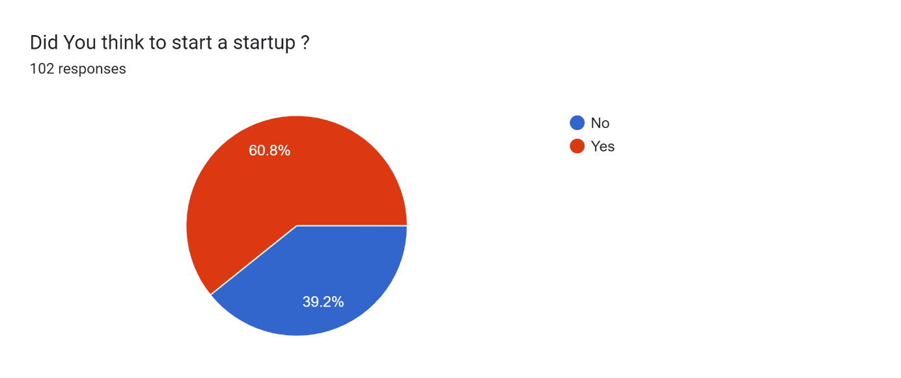

**Interpretation:**

Chart no.1 shows how many people are interested to start a startup only 39.2% are not interested and rest are willing to start a start-up.

**CHART NO.2**

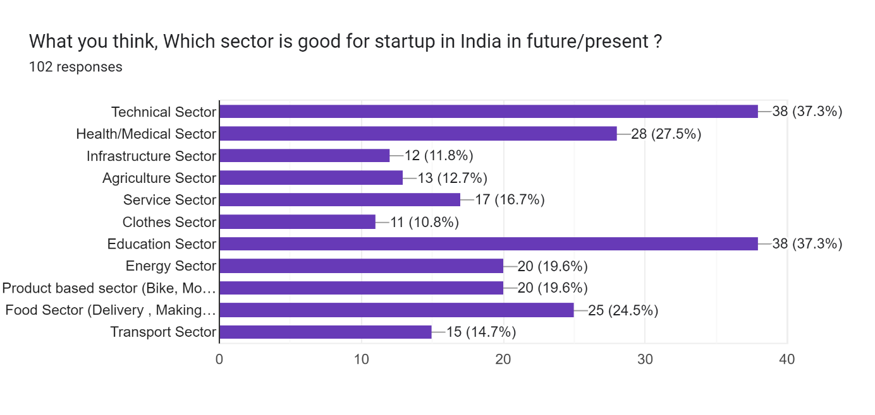

**Interpretation:**

In this particular analysis, we can see that the mass audience are interested in technical sector and Education Sector, second most is Health / Medical Sector and Food Sector. And rest are almost equal with the least interest in Infrastructure and Clothing Sector.

**CHART NO.3**

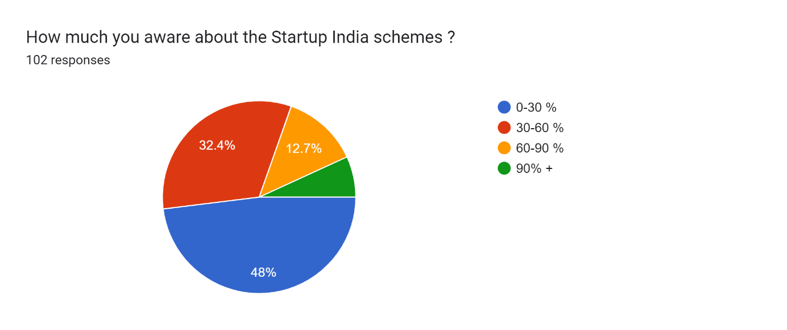

**Interpretation:**

Here We can see that only 6.9 % of audience are known much about

Government Schemes of India and the mass audience about 48% know very less about Government Schemes of India with the knowledge scale of 0-30%. And others have a moderate knowledge about the Government Schemes.

**CHART** **NO.4**

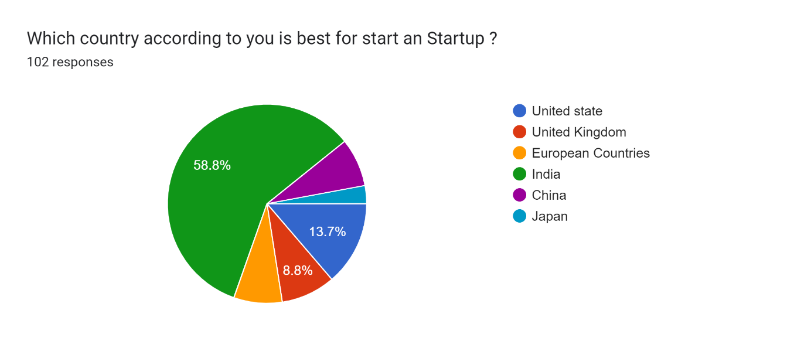

**Interpretation:**

We can see that according to the audience India is the best place to have a start-up about 59%. With Second place leading with 13.7% is United State of America and Rest are Others.

**CHART NO.5**

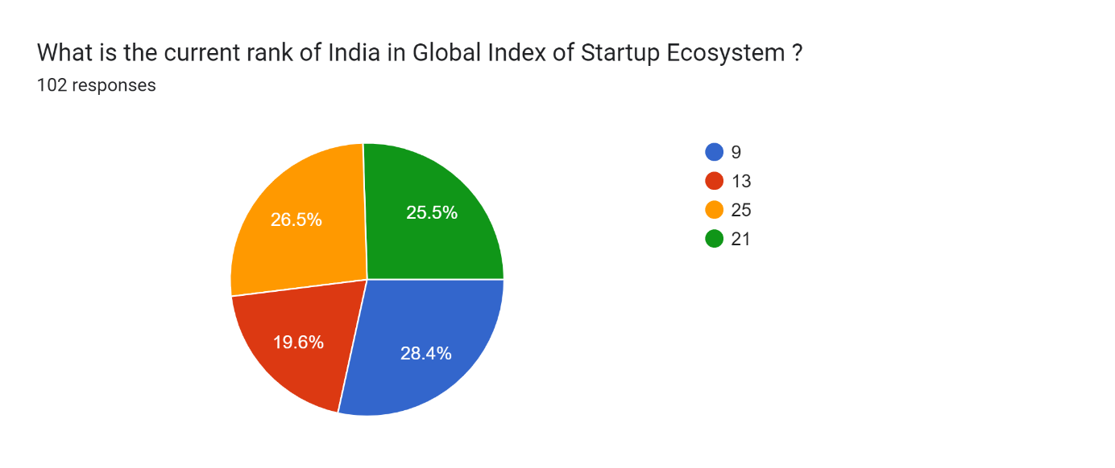

**Interpretation:**

Here we can see that about 28.4% of the audience see India rank for Global Startup Ecosystem with the rank of 9. And then we have 26.5% as rank 25 and 25.5% as rank 21. And at last, 19.6% as rank 13.

**CHART NO.6**

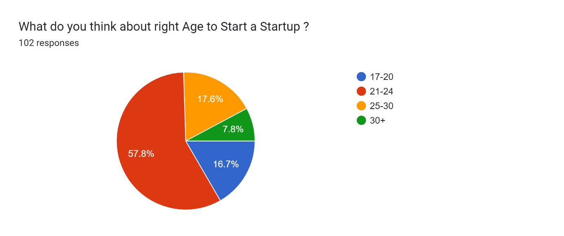

**Interpretation:**

By the Above Chart we can see that the Rightest Age to start a start a start-up is between 21-24 about 57.8% audience says that.

And we have ages in between 25-30 about 17.6% of audience.

**Chart No.7**

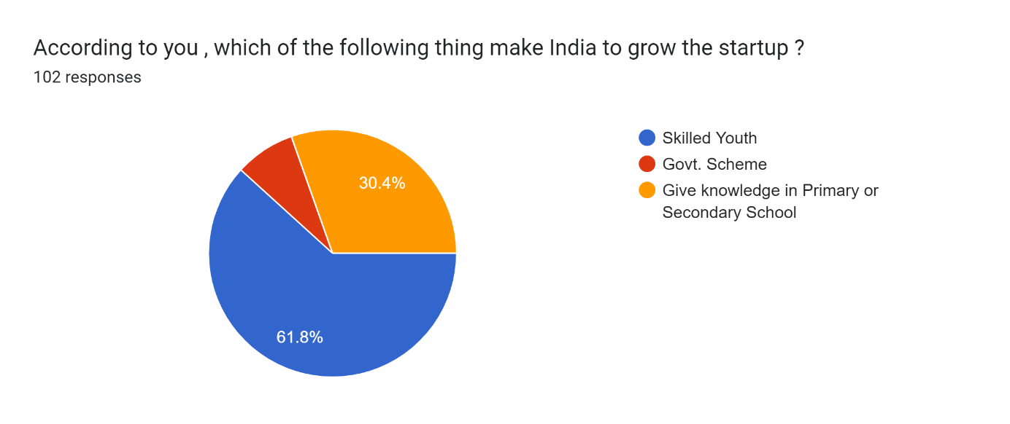

**Interpretation:**

We can see that most required thing to grow Start-up is Skilled Youth about 61.8% according to audience. And 30.4% of audience says that Give Knowledge in Primary or Secondary School is necessary.

**Chart No.8**

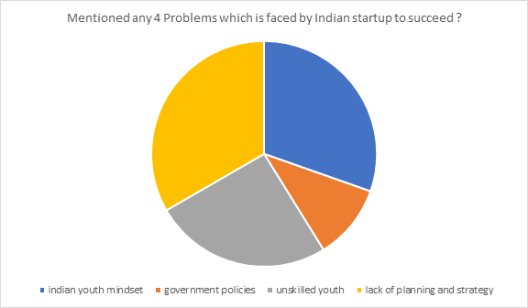

**Interpretation:**

From this we can see that there are many problems but here we mention some major problems: -

1. Lack of planning and strategy
2. Indian youth mindset
3. Unskilled youth
4. Government policies

**Secondary data:**

**Figure no.1**

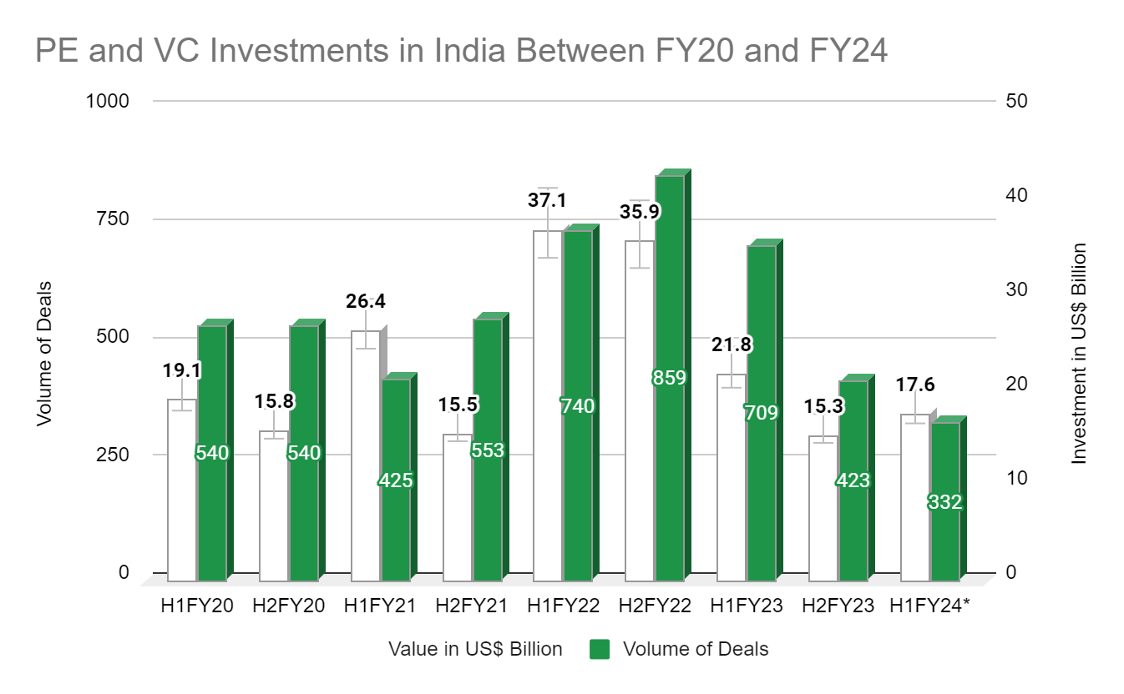

**Source :**  [**https://www.india-briefing.com/news/investment-outlook-for-indias-startup-ecosystem-in-2023-29731.html/**](%20https://www.india-briefing.com/news/investment-outlook-for-indias-startup-ecosystem-in-2023-29731.html/)

**Figure no.2**

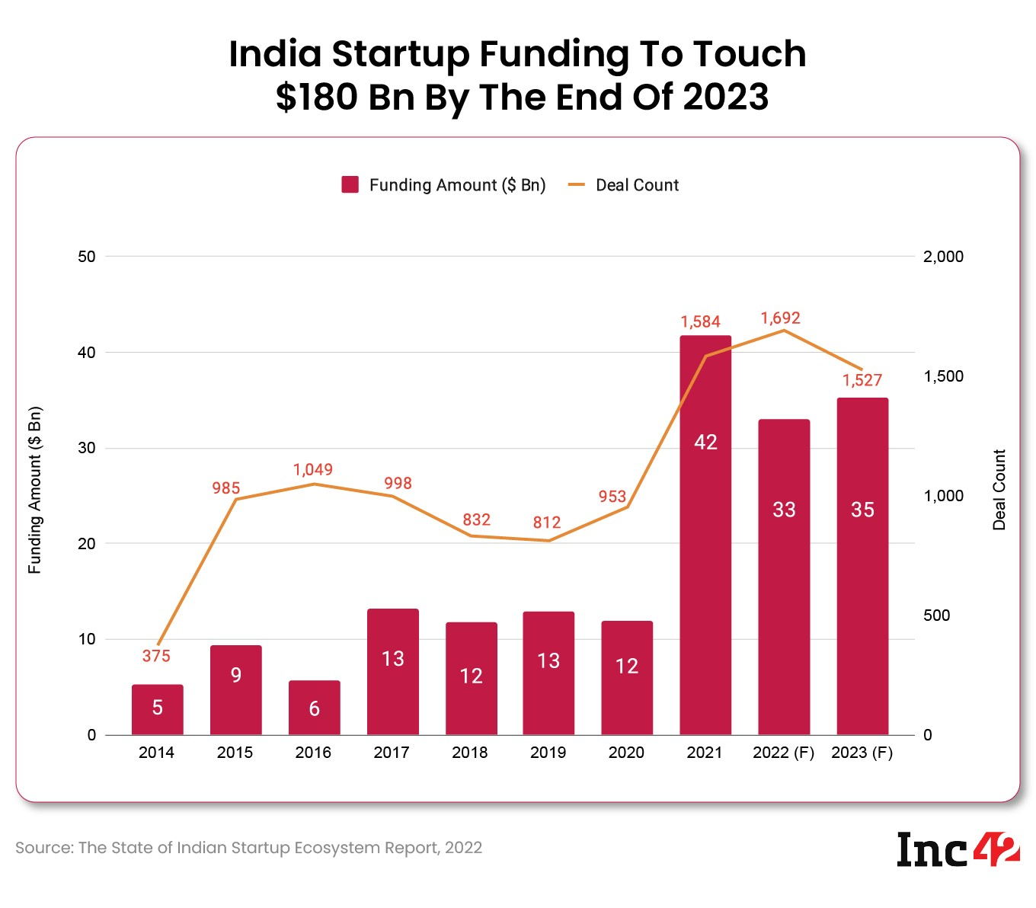**Source:** [**https://inc42.com/buzz/total-funding-indian-startups-reach-180-bn-2023/**](https://inc42.com/buzz/total-funding-indian-startups-reach-180-bn-2023/)

**Interpretation: -**

In this graph we can see that in 2023 funding amount is $35 Bn and deal count is around 1527. This is the second highest peak after 2021.

**Figure no.3**

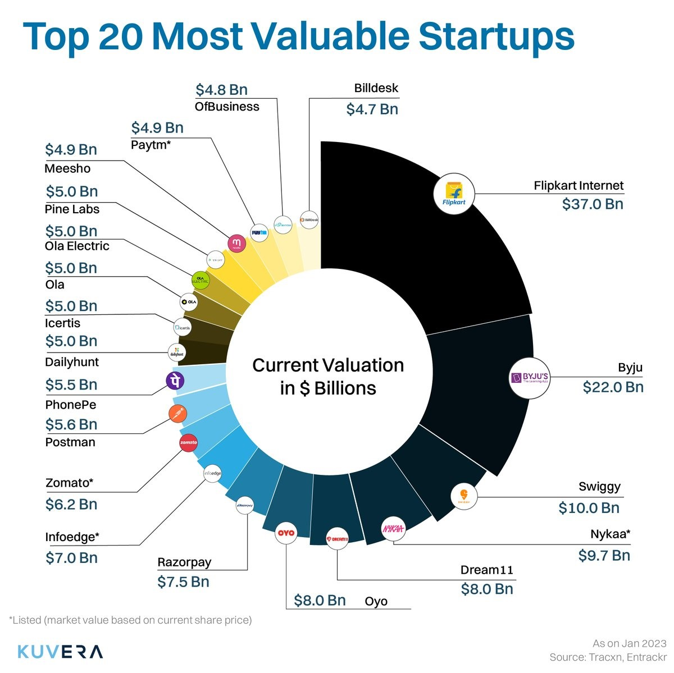

**Source:** [**https://twitter.com/Kuvera_In/status/1615705427358126082**](https://twitter.com/Kuvera_In/status/1615705427358126082)

**Interpretation: -**

Here is a look at the Indian startup ecosystem. The 3rd largest in the world after US and China. There are so many successful Indian startups, and Flipkart is the biggest and most successful startup in India.

**Figure no.4**

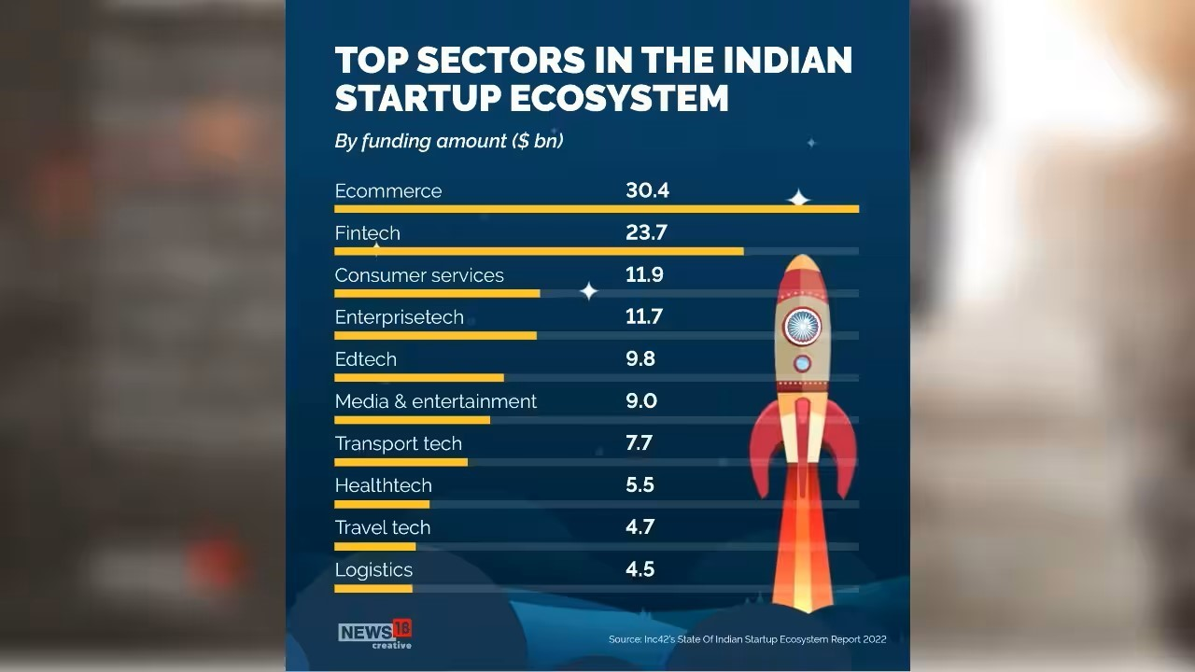

**Source:** [**https://www.moneycontrol.com/news/photos/business/startup/indian-startup-ecosystem-third-largest-in-the-world-inc42-report-shares-key-stats-9081481-4.html**](https://www.moneycontrol.com/news/photos/business/startup/indian-startup-ecosystem-third-largest-in-the-world-inc42-report-shares-key-stats-9081481-4.html)

**Interpretation: -**

As we can see most emerging sector for startup is Ecommerce like Flipkart, Myntra, Amazon, etc. After that we can see Fintech like PayPal, Paytm, etc is next and the least one is Logistics.

**Figure no.5**

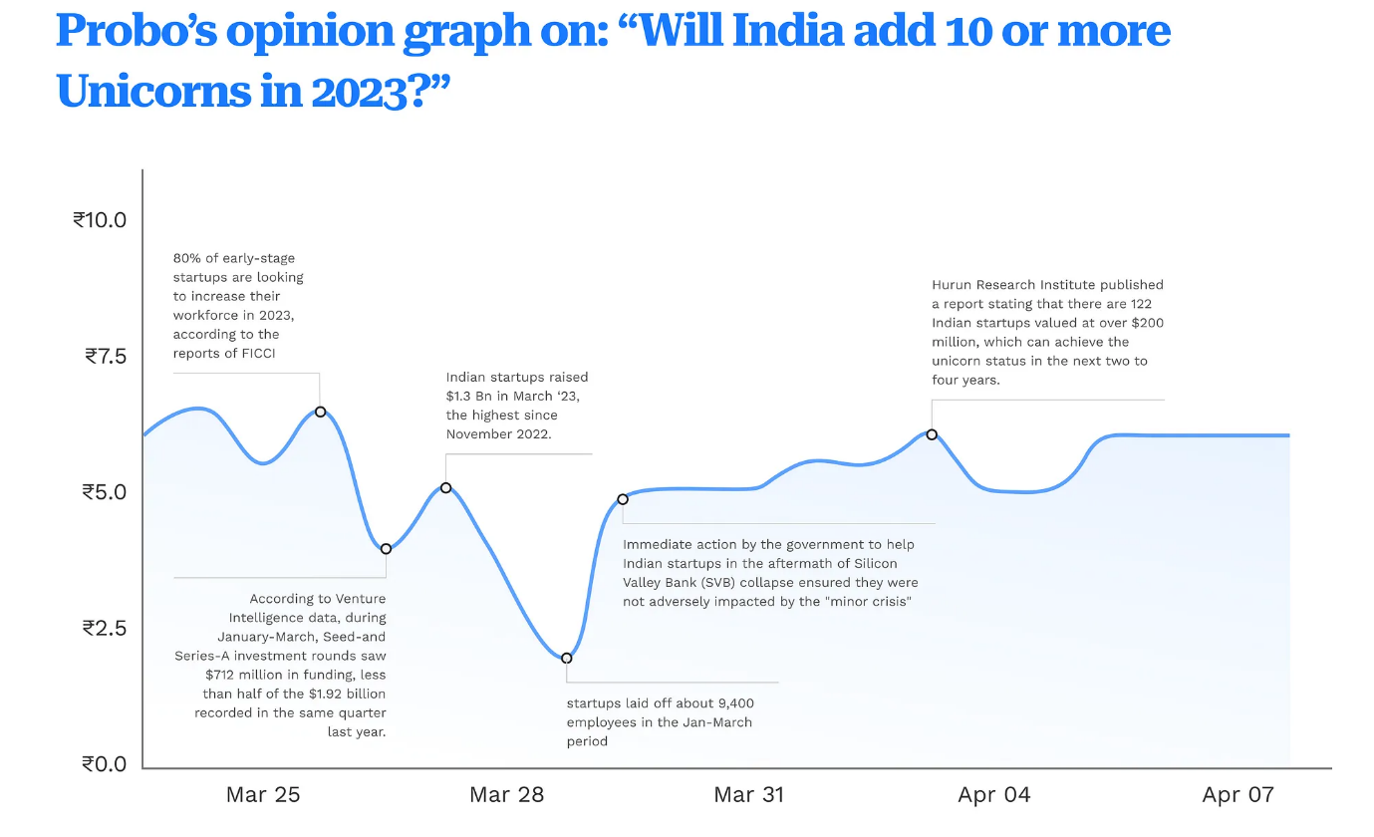

**Source:** [**https://medium.com/probo-headquarters/the-rise-of-unicorns-indias-flourishing-startup-ecosystem-5cad53cf84e5**](https://medium.com/probo-headquarters/the-rise-of-unicorns-indias-flourishing-startup-ecosystem-5cad53cf84e5)

**Interpretations: -**

Reason for yes:

1. The government is implementing policies to promote the growth of new startups in India.

In 2023, FICCI reports indicate that 80% of early-stage startups plan to expand their workforce.

**Figure no.6**

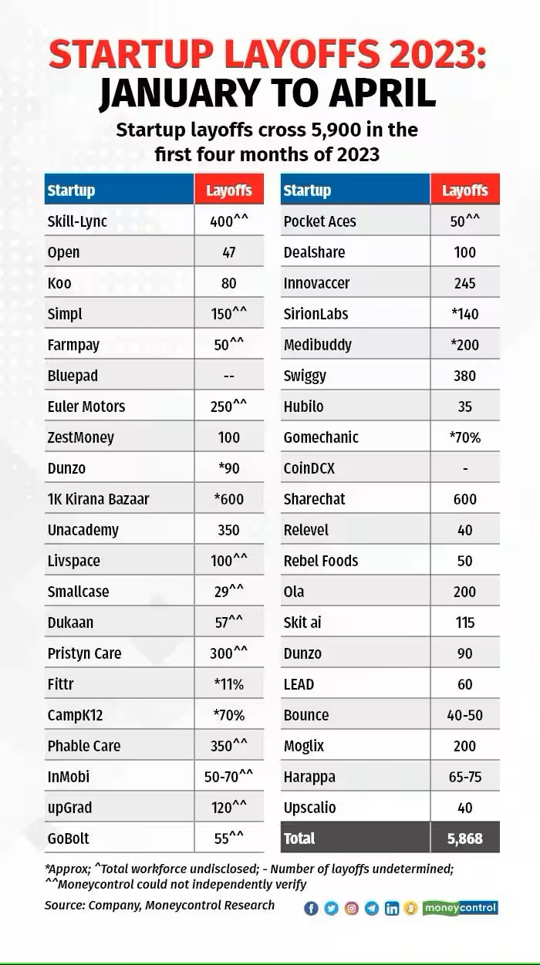

**Source:** [**https://www.moneycontrol.com/news/business/startup/indian-startups-laid-off-almost-6000-employees-in-first-four-months-of-2023-10505291.html**](https://www.moneycontrol.com/news/business/startup/indian-startups-laid-off-almost-6000-employees-in-first-four-months-of-2023-10505291.html)

**Interpretation: -**

We can see in this report around 5900 startups layoff in the first fourth moths.

There are some major startups which have a lot of lay off.

Example: 1k Kirana bazar, camp k 12, Un academy.

**Figure no.7**

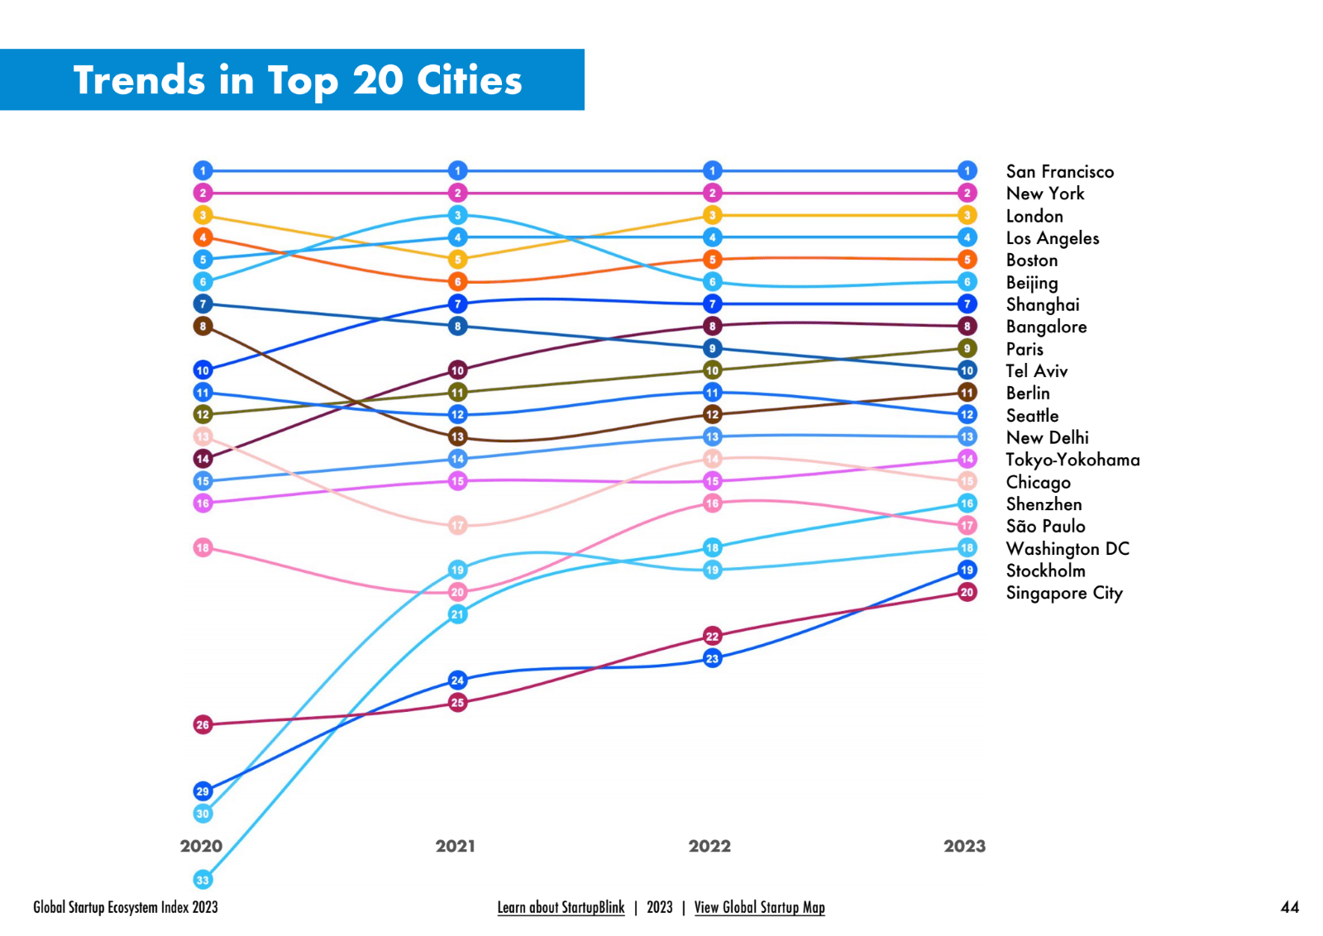

**Source:** [**https://www.startupblink.com/blog/best-cities-for-startups-in-2023/**](https://www.startupblink.com/blog/best-cities-for-startups-in-2023/)

**Figure no.8**

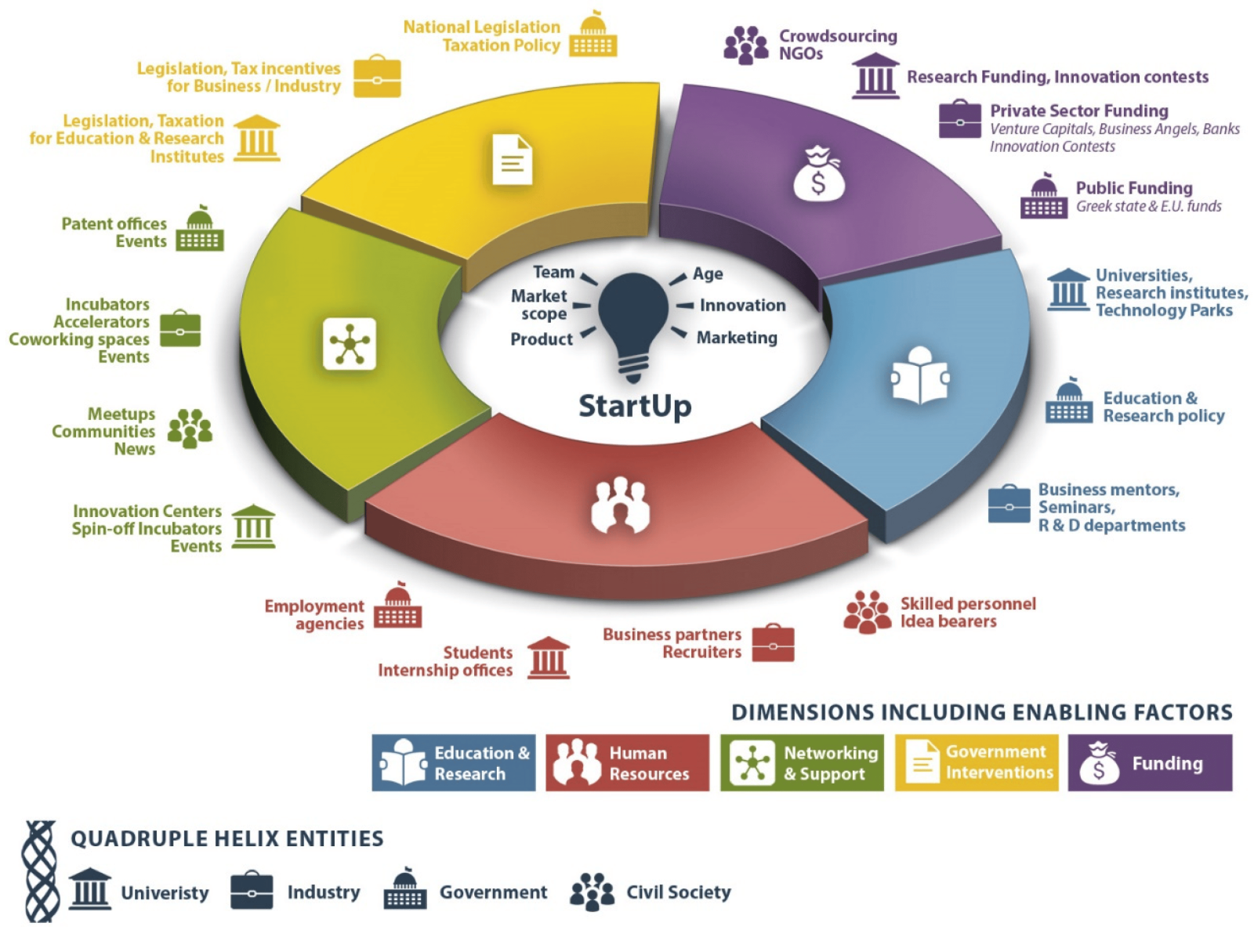

**Source:** [**https://www.mdpi.com/2199-8531/8/1/35**](https://www.mdpi.com/2199-8531/8/1/35)

**interpretation: -**

 Startups consists of these 5 things

1. Education and research
2. Human resources
3. Networking and support
4. Government intervention’s
5. Funding

We can see in the figure that these 5 things have equal weightage**.**

**Findings**:

**Primary data: -**

* Indian startups raised a record $39.6 billion in funding in 2022, according to data from venture intelligence.
* The count of Indian startups securing funding has seen a consistent rise, escalating from 1,022 in 2015 to 4,874 in 2022**.**
* The mean deal size for Indian startups has also seen growth, climbing from $5.5 million in 2015 to $8.1 million in 2022**.**
* The total valuation of Indian startups reached $120 billion in 2022, according to data from transaction.
* There are now over 100 unicorns in India, according to data from Hurun research**.**
* The total value of exits of Indian startups in 2022 was $26.4 billion.
* 1300 new tech startups were born in 2019.
* In 2021, Indian startups raised $42 billion funding, a 79% increase from the previous year.
* Indian startups created an estimated 40,000 new jobs in India.
* Women make up 14% of startup founders in India.
* Average number of employees per startups is 10.
* Number of unicorns in India:
* 2013:0
* 2014: 0
* 2015: 1
* 2016: 2
* 2017: 3
* 2018: 4
* 2019: 9
* 2020: 11
* 2021: 19
* 2022: 22

**Secondary data: -**

The number of Indian startups exiting through acquisitions or IPOs has also increased in recent years.

* In 2022, there were 48 exits of Indian startups, according to data from Venture Intelligence.
* This number is expected to grow to over 5 million by 2025.
* This growth is being driven by several factors, including a growing middle class, a young and tech-savvy population, and a government that is supportive of entrepreneurship.
* India is now home to some of the world's largest and most successful startups, such as Flipkart, Paytm, and Ola.
* Indian startups are now increasingly being founded in Tier 2 and Tier 3 cities, such as Pune, Hyderabad, and Ahmedabad.
* Startups are now operating in a wide range of sectors, including e-commerce, fintech, healthcare, education, and logistics.
* Venture capital investment in Indian startups has grown at a CAGR of 49% since 2014":
* Number of startups in India:
* 2013 - 3,100
* 2014 - 4,000
* 2015 - 5 5,000
* 2016 - 7,200
* 2017 - 10,000
* 2018 - 12,000
* 2019 - 15,000
* 2020 - 22,000
* 2021 - 27,000
* 2022 - 31,000

**Recommendations:**

* **Enhance access to funding**: To stimulate the expansion of India's startup ecosystem, it is essential to foster angel investment and venture capital funding by offering tax breaks, easing regulatory requirements, and highlighting the potential for investment returns.

* **Streamline regulatory processes:**

1. Simplify registration and compliance procedures
2. Provide regulatory support for emerging technologies

* **Nurture talent and skills**:

1. Promote synergies and partnerships between academic institutions and industrial sectors.
2. Encourage the provision of mentorship and networking platforms for individuals aspiring to become entrepreneurs.

* **Improve infrastructure and connectivity:**

1. Establish a strong physical infrastructure, encompassing transportation and logistics capabilities.
2. Facilitate availability to collaborative work environments and incubation facilities.

* **Strengthen support for women entrepreneurs:**

1. Introduce specific programs and initiatives designed to bolster startups led by women.
2. Promote role models and success stories of women entrepreneurs.

* **Address regional disparities and promote inclusive growth:**

1. Encourage startup development in tier-II and tier-III cities
2. Focus on developing solutions for local challenges and needs

* **Foster a culture of innovation and collaboration:**

1. Encourage open innovation and knowledge sharing
2. Promote partnerships between startups and established businesses

**CONCLUSION**

In conclusion, our in-depth analysis of data collected from both college students and working professionals' sheds light on the vibrant landscape of the Indian startup ecosystem. The findings underscore a significant enthusiasm and inclination towards entrepreneurship, with a notable 60.8% of respondents expressing a keen interest in initiating their own startups.

The survey revealed a particular resonance towards the technical and educational sectors, indicating a growing awareness of the potential in these domains. However, a striking 48% of the participants admitted to lacking sufficient knowledge about government schemes that could potentially aid their entrepreneurial endeavours. This highlights a critical gap in information dissemination, emphasizing the need for increased awareness programs to ensure that aspiring entrepreneurs are well-informed about the support available to them.

Despite this knowledge gap, a promising 58.8% of respondents view India as the optimal country to embark on a startup journey. This positive sentiment toward the Indian startup ecosystem underscores the potential and opportunities perceived by the youth and working professionals.

However, the survey also brought to light certain challenges hindering the startup landscape. The mindset of the Indian youth, though skilled, appears to be a stumbling block, possibly due to a lack of exposure to the intricacies of entrepreneurship. Additionally, the survey indicated that a significant portion of respondents faced obstacles in the form of insufficient planning and strategy, reflecting the need for targeted interventions to enhance entrepreneurial education and strategic thinking.

In conclusion, while the Indian startup ecosystem is marked by a high level of interest and optimism, there are areas that demand immediate attention and intervention. Bridging the knowledge gap regarding government schemes, fostering an entrepreneurial mindset among the youth, and providing support for effective planning and strategy are crucial steps toward fortifying the foundation of the Indian startup ecosystem. As the nation continues to evolve as a global hub for innovation, addressing these challenges will be instrumental in ensuring sustained growth and success for aspiring entrepreneurs.

**SCOPE FOR FUTURE RESEARCH**

**Government schemes awareness:**

**1. Identification of Knowledge Gaps:**

* Conduct surveys and interviews to identify specific areas where entrepreneurs lack knowledge about government schemes.
* Analyse the demographic factors that might contribute to these knowledge gaps, such as education level, location, and industry sector.

2. **Assessment of Information Channels:**

* Evaluate the effectiveness of current channels through which information about government schemes is disseminated, such as government websites, industry associations, and startup events.
* Identify the most and least effective channels for reaching different segments of the entrepreneurial community.

3. **Barriers to Awareness:**

* Investigate the barriers that prevent entrepreneurs from accessing information, such as language barriers, complex terminology, or lack of online presence.
* Explore regional variations in awareness and assess the role of cultural and societal factors.

**Recommendations for Improving Awareness:**

1. **Communication Strategy Enhancement:**

* Propose improvements to the communication strategy for government schemes, including the use of plain language, targeted messaging, and multilingual content.
* Suggest the integration of digital marketing and social media to reach a broader audience.

2. **Interactive Platforms and Workshops:**

* Recommend the creation of interactive platforms and workshops where entrepreneurs can directly engage with government officials and experts to understand the nuances of available schemes.
* Explore the feasibility of virtual sessions to enhance accessibility.

3. **Collaboration with Educational Institutions:**

* Propose collaborations with educational institutions to integrate information about government schemes into entrepreneurship courses.
* Encourage the inclusion of practical workshops and case studies to familiarize students with the application processes.

4. **Localized Awareness Campaigns:**

* Advocate for localized awareness campaigns that address region-specific challenges and opportunities.
* Collaborate with local influencers and industry leaders to enhance the credibility and reach of these campaigns.

5. **Feedback Mechanism Improvement:**

* Suggest the implementation of a robust feedback mechanism where entrepreneurs can provide input on their experiences with government schemes.
* Propose regular assessments of the feedback received to adapt and improve schemes based on real-world experiences.

**Lack of Planning and Strategy:**

The perceived lack of planning and strategy in startup initiatives among Indian college students and working professionals warrants a comprehensive investigation to uncover the underlying factors contributing to this phenomenon. This inquiry extends beyond the individuals themselves and delves into the realms of educational curricula, mentorship programs, and other support structures that form the foundation of entrepreneurial development.

* One key aspect to explore is the alignment between educational curricula and the practical demands of entrepreneurship. Traditional academic structures may not be adequately equipping aspiring entrepreneurs with the essential skills for strategic planning. A meticulous analysis of existing courses, especially those in business and management, is imperative. Evaluating whether these courses integrate real-world case studies, scenario-based learning, and practical exercises related to startup planning can reveal gaps that need addressing. Collaborations between academic institutions and industry experts may facilitate the infusion of practical insights into the educational framework, ensuring that students graduate with a strategic mindset.

Mentorship programs play a pivotal role in guiding aspiring entrepreneurs, yet their effectiveness is contingent on their structure and accessibility. Investigating the current mentorship landscape can identify potential shortcomings. Lack of mentorship opportunities, mismatched mentor-mentee pairings, or insufficient emphasis on strategic planning within these programs could be contributing factors. Recommendations should emphasize the need for mentorship programs tailored to address the specific challenges of startup planning. Initiatives fostering mentor networks, both within educational institutions and the broader entrepreneurial ecosystem, can bridge the existing gaps and provide invaluable guidance to budding entrepreneurs.

Furthermore, examining the support structures available to startups is crucial. Identifying the prevalence and quality of incubators, accelerators, and entrepreneurship centers can shed light on the resources available for strategic planning. If these support mechanisms primarily focus on initial ideation and lack sustained guidance on strategic development, adjustments are necessary. Recommendations should advocate for the expansion of these support structures to include modules on strategic planning, helping entrepreneurs navigate challenges beyond the ideation phase.

In fostering a more strategic approach to startup planning, a holistic strategy is needed. Proposals should address educational reforms, mentorship program enhancements, and the augmentation of support structures. Emphasizing the integration of practical, real-world scenarios into educational curricula, expanding mentorship opportunities, and enriching support structures with strategic planning modules can collectively contribute to a more prepared and strategic cohort of entrepreneurs. Ultimately, the goal is to cultivate a startup ecosystem where planning and strategy are ingrained components of entrepreneurial DNA, propelling ventures towards sustainable success.

BIBLIOGRAPHY:

1. <http://Researchgate.net>
2. [10.pdf (amity.edu)](https://www.amity.edu/arjtah/pdf/vol1-2/10.pdf)
3. [Microsoft Word - WP 514 - Fakih Amrin Kamaluddin (isec.ac.in)](http://www.isec.ac.in/WP%20514%20-%20Fakih%20Amrin%20Kamaluddin%20-%20Final.pdf)
4. <https://papers.ssrn.com/sol3/papers.cfm?abstract_id=3245938>
5. [IRJET-V8I1156.pdf](https://www.irjet.net/archives/V8/i11/IRJET-V8I1156.pdf)
6. [Administrative Sciences | Free Full-Text | Success Factors of Startups in Research Literature within the Entrepreneurial Ecosystem (mdpi.com)](https://www.mdpi.com/2076-3387/12/3/102)
7. <https://www.sdcollegeambala.ac.in/wp-content/uploads/2021/08/eedi2020-25.pdf>
8. <https://in.docs.wps.com/l/sIB-t6-PgAci93KoG?v=v2>
9. **https://www.india-briefing.com/news/investment-outlook-for-indias-startup-ecosystem-in-2023-29731.html/**
10. [**https://inc42.com/buzz/total-funding-indian-startups-reach-180-bn- 2023/**](https://inc42.com/buzz/total-funding-indian-startups-reach-180-bn-%20%20%20%20%20%20%20%202023/)
11. [**https://twitter.com/Kuvera_In/status/1615705427358126082**](https://twitter.com/Kuvera_In/status/1615705427358126082)
12. [**https://www.moneycontrol.com/news/photos/business/startup/indian-startup-ecosystem-third-largest-in-the-world-inc42-report-shares-key-stats-9081481-4.html**](https://www.moneycontrol.com/news/photos/business/startup/indian-startup-ecosystem-third-largest-in-the-world-inc42-report-shares-key-stats-9081481-4.html)
13. [**https://medium.com/probo-headquarters/the-rise-of-unicorns-indias-flourishing-startup-ecosystem-5cad53cf84e5**](https://medium.com/probo-headquarters/the-rise-of-unicorns-indias-flourishing-startup-ecosystem-5cad53cf84e5)
14. [**https://www.moneycontrol.com/news/business/startup/indian-startups-laid-off-almost-6000-employees-in-first-four-months-of-2023-10505291.html**](https://www.moneycontrol.com/news/business/startup/indian-startups-laid-off-almost-6000-employees-in-first-four-months-of-2023-10505291.html)
15. [**https://www.startupblink.com/blog/best-cities-for-startups-in-2023/**](https://www.startupblink.com/blog/best-cities-for-startups-in-2023/)
16. [**https://www.mdpi.com/2199-8531/8/1/35**](https://www.mdpi.com/2199-8531/8/1/35)

Appendix:

<https://docs.google.com/forms/d/e/1FAIpQLSfzzn3SiMH53dejFxOq__-sdvK7Gu6WbVGLTwHlEWvF0wwlcw/viewform?usp=sf_link>